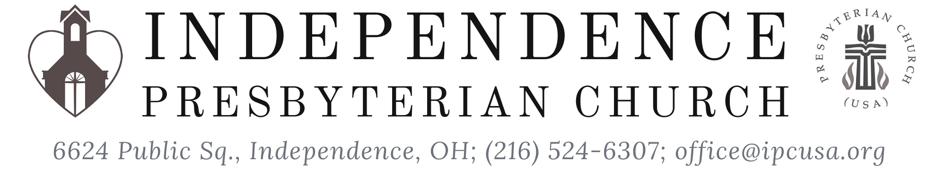
Ascension of the Lord
May 16, 2021

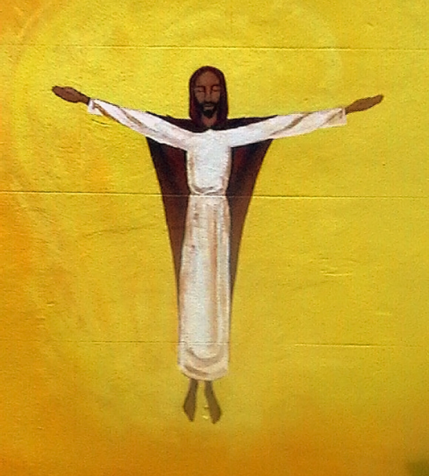
Ascension, Mural on Graffiti Wall; Bristol, England

C.J. Briggs, Music Director
Julie Lehmann, Secretary
John Bair, Liturgist
Rev. David B. Wigger, Pastor
“The Ascension is a festival of the future of the world’”
~Karl Rahner
~ Gathering ~
Gathering Music
Litany for Ascension of the Lord (Repeated)
…Lift up your hearts.
We lift them to the Lord.
Welcome and Announcements
Prelude Fantasia in G Dorian SwWV270
by Jan Pieterszoon Sweelinck

Call to Worship (Based on Psalm 47)
Clap your hands, all you peoples;
shout to God with loud songs of joy.
For the Holy One, the Most High, is awesome,
a great sovereign over all the earth.
God has gone up with a shout,
the Lord with the sounds of a trumpet.
Sing praises to the Holy One, sing praises;
sing praise to our God, sing praises.
For God is the sovereign of all the earth;
sing praises with a psalm.
Come, let us worship God.
Hymn At the Name of Jesus GTG #261
by Caroline Maria Noel king’s weston

Children’s Moment The Good News Desmond Tutu

from the “Children of God Storybook Bible” (Acts 1)
Children may be dismissed to Sunday School.
Pouring of the Baptismal Waters

Prayer of Confession
Almighty God, you have raised Jesus from death to life, and crowned him Lord of all. We confess that we have not bowed before him, or acknowledged his rule in our lives. We have gone along with the ways of the world, and failed to give him glory. Forgive us, and raise us from sin, that we may be your faithful people, obeying the commands of our Lord Jesus Christ, who rules the world and is head of the church, his body. [Time of Silent Confession]
Response Be Not Afraid GTG #243
Taizé Community and Jacques Berthier be not afraid
Assurance of Pardon
The God of all grace, who calls us to eternal glory in Jesus Christ, will restore, support, and strengthen us.
In the name of Jesus Christ, we are forgiven! Thanks be to God.
Passing of the Peace
The peace of Christ be with you. And also with you.
Alleluia Halle, Halle, Hallelujah! GTG #591
Caribbean melody; arr. by John L. Bell halle halle
~ The Word ~

Prayer of Illumination
First Reading Luke 24:44-53 (NRSV)
Hear what the Holy Spirit is telling God’s people.
Thanks be to God.
Psalm 47 Peoples, Clap Your Hands! GTG #261
by Joy F. Patterson genevan 47
Second Reading Acts 1:1-11 (NRSV)
Sermon Rev. Wigger
Affirmation of Faith (from 1 Cor. 15, Mk 16, Mt 16, Rev. 22, Jn 20)
This is the good news which we have received, in which we stand, and by which we are saved, if we hold it fast: that Christ died for our sins according to the Scriptures, that he was buried, that he was raised on the third day and that he appeared first to the women, then to Peter, and to the Twelve, and then to many faithful witnesses. We believe that Jesus is the Christ, the Son of the living God. Jesus Christ is the first and the last, the beginning and the end; he is our Lord and our God. Amen.
~ Responding to the Word ~
Invitation to the Offering
Response Doxology GTG #606
Words by Thomas Ken old hundredth
Prayer of Dedication
Prayers of the People
~ SENDING ~
Hymn Our God Is an Awesome God GTG #616
By Rich Mullens
Benediction (Based on Psalm 47)
Postlude Fugue in C Major BuxWV174
Dietrich Buxtehude

Coffee and tea are available in the gathering room. You are invited to grab a cup and head to the courtyard for (socially-distanced) fellowship.
Pieces of today’s liturgy are from: the Book of Common Worship, PC(USA); Together We Pray, by J. Bradley Wigger and the Presbyterian Outlook, Matt Rich. GTG = “Glory to God” Hymnal

