Good Friday
Thursday, April 1, 2021

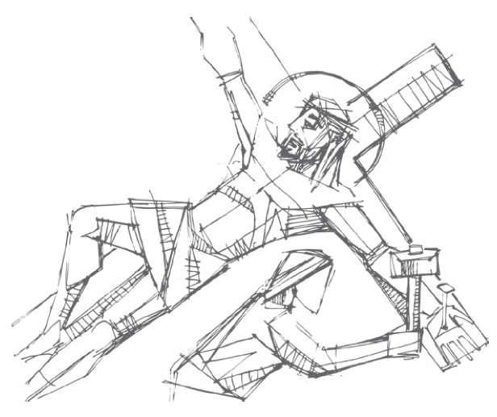

Good Friday proclaims the good news of salvation through the paradoxical suffering and death of our Lord Jesus Christ. The center of this liturgy is the reading of the passion narrative from the Gospel of John, in which Christ is lifted up on the cross as a sign of God’s great love for the world. -PCUSA Book of Common Worship
Service begins with the Christ candle and candelabras are lit.
Opening Sentences
Christ Jesus bore our sins in his body on the cross
so that we might die to sin and live for righteousness.
Blessed is the name of the Lord.
Prayer
Extinguish one candle.
Hymn Balm of Gilead (Joe – Clarinet)
Extinguish one candle.
Prayer of Illumination
Gospel John 18:1-19:42 (NRSV)
Reader 1: Betrayal and Arrest of Jesus (John 18:1-11)
Response: “This Is the Night” GTG #206 Verse 1
Extinguish one candle.
Reader 2: Jesus Before the High Priest (John 18:12-14)
Response: “This Is the Night” GTG #206 Verse 2
Extinguish one candle.
Reader 1: Peter Denies Jesus (John 18:15-18)
Response: “This Is the Night” GTG #206 Verse 3
Extinguish one candle.
Reader 2: The High Priest Questions Jesus (John 18:19-23)
Response: “This Is the Night” GTG #206 Verse 4
Extinguish one candle.
Reader 1: Peter Denies Jesus Again (John 18:25-27)
Response: “This Is the Night” GTG #206 Verse 5
Extinguish one candle.
Reader 2: Jesus Before Pilate (John 18:28-38a)
Response: “Were You There” GTG #228 Verse 1
Extinguish one candle.
Reader 1: Jesus Sentenced to Death (John 18:38b-19:16a)
Response: “Were You There” GTG #228 Verse 2
Extinguish one candle.
Reader 2: The Crucifixion of Jesus (John 19:16b-30)
Response: “Were You There” GTG #228 Verse 3
Extinguish one candle.
Reader 1: Jesus’ Side Is Pierced (John 19:31-37)
Response: “Were You There” GTG #228 Verse 4
Extinguish one candle.
Reader 2: The Burial of Jesus (John 19:38-42)
Response: “Were You There” GTG #228 Verse 5
Extinguish one candle.
Hymn (Psalm 22) GTG#210
Extinguish one candle.
Solemn Reproaches of the Cross
After each reproach, the congregation may respond:
…but you have made a cross for your savior
Holy God,
Holy and mighty,
Holy immortal One,
have mercy on us.
Extinguish one candle.

Were You There? (Jazz Version)
Extinguish the Christ candle.

All depart in silence.

Pieces of today’s liturgy are from the Book of Common Worship, PC(USA); and Presbyterian Outlook, Roger Gench. Greeting prayer by Rebecca Gresham-Kesner.

