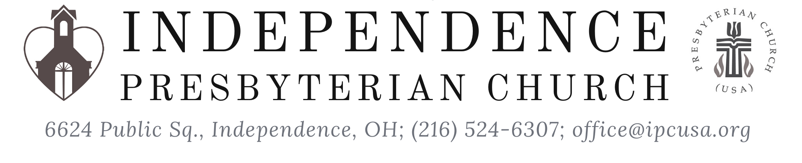
Maundy Thursday
Thursday, April 1, 2021

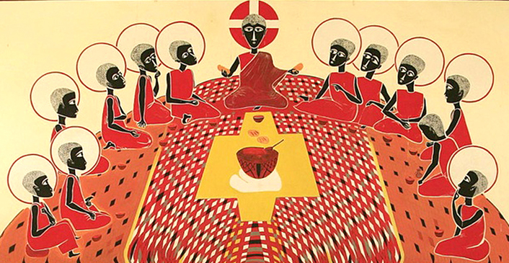
Saget, Father George; The Last Supper

C.J. Briggs, Music Director
Rev. David B. Wigger, Pastor

Maundy Thursday (from mandatum, Latin for commandment) proclaims Jesus’ new commandment to love one another as he has loved us. It celebrates Christ’s example of humble service and self-offering, represented by the washing of feet and the sharing of communion. The liturgy begins with an emphasis on confession and forgiveness, concluding the penitential season of Lent. It ends with the stripping of the church in preparation for worship on Good Friday.”
-PCUSA Book of Common Worship

Opening Prayer
Jesus said: I give you a new commandment,
that you love one another
This is how everyone will know we are disciples,
when we love each other.
Greeting and Prayer
Beloved people of God:
This is the day
when Christ, our Passover Lamb,
surrendered himself to those who would kill him,
setting us free from sin and death forever.
This is the day
when Christ, our Teacher and Lord,
knelt down to wash the disciples’ feet,
showing us how to love and serve one another.
This is the day
when Christ, the bread of heaven,
shared a holy meal with his followers,
offering a feast of abundant life and grace for all.
Hymn Jesu, Jesu, Fill Us With Your Love GTG# 203
Ghanaian folk melody; adapt. by Tom Colvin; arr. Jane Marshall

Confession
Eternal God, whose covenant with us is never broken, we confess that we fail to fulfill your will. Though you have bound yourself to us, we will not bind ourselves to you. In Jesus Christ you serve us freely, but we do not love you fully or love one another as you command. In your mercy, forgive and cleanse us.
Lead us once again to your table and unite us to Christ, who is the bread of life and the vine from which we grow in grace.

Response Kyrie Eleison C.J. Briggs

Assurance of Pardon

Passing of the peace
The peace of Christ be with you.
And also with you.

Prayer of Illumination
Gospel Reading John 13:1-17, 31-35 (NRSV)
Hear what the Holy Spirit is telling God’s people.
Thanks be to God.
Invitation to Serve
Prayers of Intercession
Lord in your mercy,
hear our prayer.
Invitation to the Lord’s Table
The Lord be with you.
And also with you.
Lift up your hearts.
We lift them up to the Lord.
Let us give thanks to the Lord our God.
It is right to give our thanks and praise.
Therefore we praise you,
joining our voices with the celestial choirs
and with all the faithful of every time and place,
who forever sing to the glory of your name:
Holy, holy, holy Lord, God of power and might, heaven and earth are full of your glory. Hosanna in the highest. Blessed is the one who comes in the name of the Lord. Hosanna in the highest.
Breaking of the Bread
The gifts of God for the people of God.
Thanks be to God.
Communion
There is an outer seal accessing the wafer and an inner seal accessing the juice.
Please take, and discard, your cup when you leave.
Hymn An Upper Room Did Our Lord Prepare GTG #202
English folk melody (o waly waly); harm. John Weaver
Text: Fred Pratt Green
Prayer after Communion
Stripping of the Church
There is no benediction. The service continues (virtually) on Good Friday.
All depart in silence.

Pieces of today’s liturgy are from the Book of Common Worship, PC(USA);
Words of Institution arr. by Rev. Veronica Goines

