Third Sunday of Advent
December 13, 2020

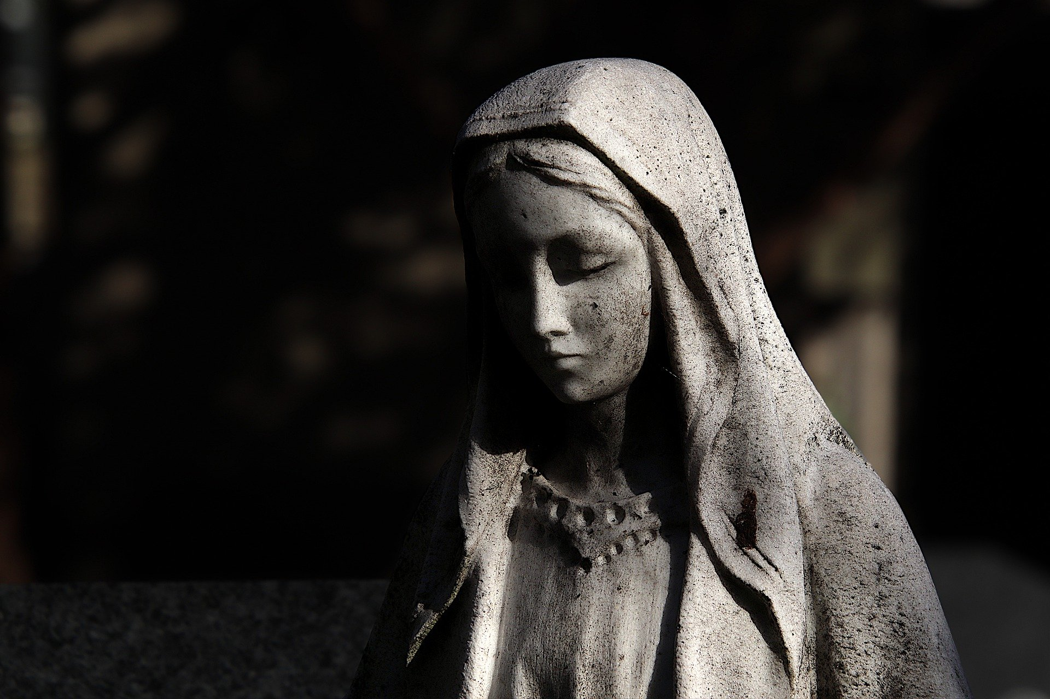

C.J. Briggs, Music Director
Julie Lehmann, Secretary
Ryan McGovern, Liturgist
Rev. David B. Wigger, Pastor

God is awesome, clap for joy. [clap once]
God is awesome, clap again. [clap twice]
Amen. [clap three times]
-J. Bradley Wigger
Gathering
Prelude
Welcome and Announcements
Presentation of Candidates for Deacon and Elder
Deacons: Connie Smith, Dean Jermann
Elders: Ryan McGovern, Janis Carr, Laura Butler, Wendy Lavey
Lighting the Advent Candles
In this season of longing,
we light these candles in sadness and in joy,
as a reminder of the coming light of Christ
As the Holy One has promised, in days to come:
The wilderness and the dry land shall be glad,
the desert shall rejoice and blossom;
like the rose that grew from concrete,
the earth will learn to breathe fresh air
and rejoice with joy and singing.
In joy, let us walk in the light of the Holy One. Amen.
Response “Clear Out the Crowded Heart” Austin Echols

Call to Worship (based on Luke 1)* Ryan McGovern
My soul magnifies the Lord,
and my spirit rejoices in God my Savior.
God has looked with favor on this servant.
Surely, all generations will call me blessed.
For the Mighty One has done great things for me.
God’s mercy is from generation to generation.
God’s strength brings down the powerful, and lifts the lowly.
The Holy One fills the hungry, and sends away the rich.
The covenant is kept in faithfulness,
from generation to generation.
In the light of joy, come let us worship God.
Hymn “My Soul Gives Glory” GTG #99
Words by Miriam Therese Winter; Music arr. C. Winfred Douglass

Prayer of Confession (in unison)
Merciful God, you love righteousness; why, then, do we persist in wrongdoing and every form of evil? You have given us the gift of your Spirit; why, then, do we quench the Spirit among us? You have given us the words of the prophets and the Word himself; why, then, do we despise and ignore what we have heard from you? You have sent the light in the world; why, then, have we loved darkness rather than light? Forgive us. Restore us. Till and tend us as your garden until righteousness and praise spring up, for the sake of Jesus Christ, in whose name we pray. Amen. [Time of Silent Confession.]
Response “O Come, O Come Emmanuel” GTG #88

Assurance of Pardon
Friends, hear the good news of the gospel:
we are forgiven and restored, set on right paths of justice and peace.
Passing of the Peace
The peace of Christ be with you.
And also with you.

The Word
Children’s Moment

Prayer of Illumination
Hebrew Bible Isaiah 61:1-3, 10-11 (NRSV)
Gospel John 1:6-8, 19-28 (NRSV)
Hear what the Holy Spirit is telling God’s people.
Thanks be to God.
Sermon Longing for Joy Rev. David Wigger
Responding to the Word
Ordination and Installation
Sentences of Scripture
There are varieties of gifts,
but it is the same Spirit who gives them.
There are different ways of serving God,
but it is the same Lord who is served.
God works through each person in a unique way,
but it is God’s purpose that is accomplished.
To each is given a gift of the Spirit
to be used for the common good.
Profession
With the whole church, let us confess our faith.
Do you believe in God the Father?
I believe in God, the Father almighty, creator of heaven and earth.
Do you believe in Jesus Christ, the Son of God?
I believe in Jesus Christ, God’s only Son, our Lord, who was conceived by the Holy Spirit,
born of the Virgin Mary,
suffered under Pontius Pilate,
was crucified, died, and was buried; he descended to the dead.
On the third day he rose again;
he ascended into heaven,
he is seated at the right hand of the Father,
and he will come to judge the living and the dead.
Do you believe in God the Holy Spirit?
I believe in the Holy Spirit, the holy catholic church, the communion of saints, the forgiveness of sins,
the resurrection of the body, and the life everlasting. Amen.

Offering
Response “Come, Thou Long-Expected Jesus” GTG #82
Prayer of Thanksgiving
Prayers of the People
The Lord’s Prayer
Our Father who art in heaven, hallowed be thy name. Thy kingdom come, thy will be done, on earth as it is in heaven. Give us this day our daily bread; and forgive us our debts as we forgive our debtors; and lead us not into temptation but deliver us from evil. For thine is the kingdom and the power and the glory, forever. Amen.

Sending
Hymn “Canticle of the Turning” GTG #100
by Rory Cooney

Advent Charge
Postlude

Pieces of today’s liturgy are from Presbyterian Outlook, Roger Gench;
Feasting on the Word, ed. Kimberly Bracken Long; and
Together We Pray, J. Bradley Wigger

GTG = Glory to God (PCUSA Hymnal)

*For all responsive liturgy, leader will read the parts in regular type,
and the congregation may respond with the words in bold.

News and Announcements

At this time Independence Presbyterian Church is planning on holding two Christmas Eve services this year. Both services will be in-person and live-streamed. Each service can hold up to 50 people in-person (25% of the sanctuary capacity) with COVID protocols in place. If you would like to attend one of the services in-person, please sign-up by filling out the form on our website, or calling or emailing the office. We ask for you to provide contact information in case of cancellation due to the coronavirus. Here is the link: bit.ly/christmasIPC
The city of Independence has put out a request for bell ringers for the Salvation Army. COVID19 has had a damaging impact on the S.A. and volunteer participation is significantly lower this year. The specific day's they are requesting help are every Thursday, Friday and Saturday from November 27th through December 24. The shifts begin at 10am and end at 6pm and are assigned in 1 hour increments. The location is the Giant Eagle located at I-77 and Route 82. To volunteer contact Independence Community Services at 216-524-7373.

We are still collecting Pledge cards for our stewardship campaign. You can mail them back or if you would like to drop them off, there is a collection stand just inside the main door to the church. The office hours are Monday through Thursday 9am-12pm or you can bring it when you come to worship.
***We have been told by a few congregants that they have not received their cards, also we have had some returned as undeliverable through the mail. We believe we have remedied the situation, but in case you still have not received one, let us know and we will certainly get another to you.

Tuesday, December 15
Mission Meeting, 7pm

Wednesday, December 16
Session Meeting, 7pm

Thursday, December 17
Property and Finance, 7pm

Sunday, December 20
Fourth Sunday of Advent

Thursday, December 24
Christmas Eve Service, 5 pm
Christmas Eve Service, 8 pm

Daily Prayers for Advent Reflection: Week 3
December 13-19

Sunday: God of hope, you call us home from the exile of selfish oppression to the freedom of justice, the balm of healing, and the joy of sharing.

Monday: Make us strong to join you in your holy work, as friends of strangers and victims, companions of those whom others shun.

Tuesday: God of joy and exultation, you strengthen what is weak; you enrich the poor and give hope to those who live in fear.

Wednesday: God of joy…look upon our needs this day. Make us grateful for the good news of salvation and keep us faithful un your service until the coming of our Lord Jesus Christ, who lives for ever and ever.

Thursday: Merciful God of peace, your work, spoken by the prophets, restores your people’s life and hope.

Friday: Fill our hearts with the joy of your saving grace, that we may hold fast to your great goodness and in out lives proclaim your justice in all the world.

Saturday: Light of life, you came in flesh and gave us power to be your children. Grant us faith, O Christ, to see your presence among us, so that all of creation may sing new songs of gladness and walk in the way of peace.

From Revised Common Lectionary Prayers, based on Advent lectionary:
Isaiah 40:1-11 • Psalm 85:1-2, 8-13 • 2 Peter 3:8-15a • Mark 1:1-8

